PRW prawns

The prey included midwater (siphonophores, chaetognaths, heteropods and pteropods) and benthic forms (sponges, polychaetes, other gastropods, bivalves and echinoderms). The dominant prey were decapods crustaceans (7.9-67.2% by volume) and fish (0.5-33.0%), most of which could not be identified as midwater or demersal in origin; significant quantities of foraminiferans (1.8-15%) and squid (0.5-6.5%) were also eaten. The penaeids *Aristeus virilis. Haliporoides sibogae* and *Plesiopenaeus edwardsianus* ate mainly benthic or demersal animals.

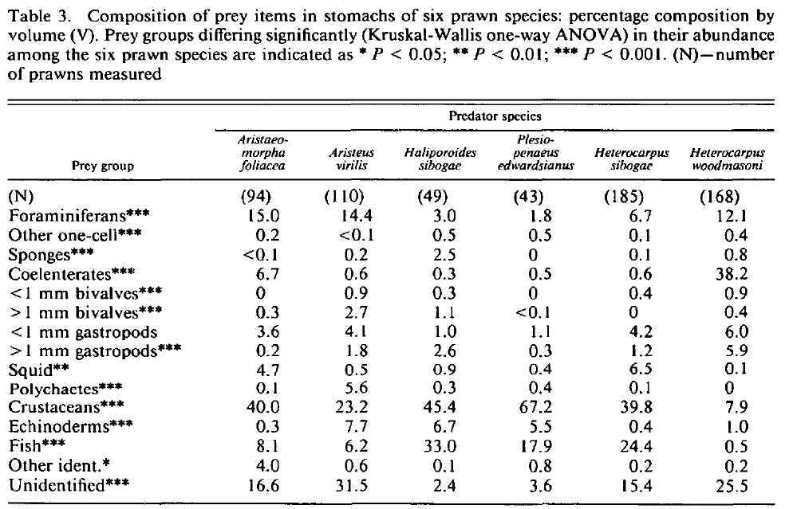

The natural diets of juvenile and adult P. esculentus are quite different, indicating a need for different diets for different life history stages (Smith et al., 1992). Additionally, there is a progressive dietary ontogeny within the juvenile phase. Small juvenile P. esculentus are predominately carnivorous but with some requirement for vegetation in their diet (Dall et al., 1992; O’Brien, 1994c). Their natural diet includes small protozoa, diatoms, algae, seagrass and zooplankton (O’Brien, 1992). As they grow, their diet changes from diatoms, to filamentous algae to seagrass with increasing amounts of small molluscs, crustaceans and other invertebrates found on seagrasses (Wassenberg and Hill, 1987; Smith et al., 1992; O’Brien, 1994c).

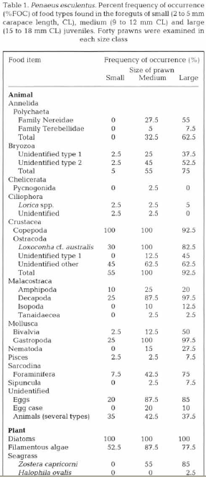

The most common food types were crustaceans (copepods, decapods and ostracods), molluscs (gastropods), diatoms, filamentous algae and seagrass. ***Penaeus esculentus*** juveniles ate a more diverse range of food types as they grew. The smallest prawns

(2 to 3 mm CL), which had recently settled out of the plankton, fed on 9 food types but they ate predominantly copepods (mainly harpacticoids and some calanoids, pers. obs.) and diatoms. Copepods and diatoms were probably the major food types captured from the plankton before the prawns settled on the seagrass bed. At about 5 mm CL (when the prawns were about 2 wk older), the prawns fed on 15 food types and, by about 9 mm CL, they were eating the full range of food recorded (up to 36 food types). Small juveniles mostly ate smaller food types such as copepods and diatoms. Larger juveniles ate prey which was more

difficult to capture and eat, such as polychaetes which hold-fast in their burrows, fast-moving decapods and large thick-shelled gastropods and foraminiferans, e.g. decapod fragments were found in only 25% of the small juvenile foreguts examined whereas they were present in 87.5 and 97.5% of the foreguts of medium and large juveniles, respectively. Interestingly, large juveniles were found to continue to eat small sized copepods and gastropods. Diatoms were found in the foreguts of all prawns (100%FOC). Twenty-eight genera of diatoms were identified and a common range of diatom types was eaten by all sizes of juvenile (Table 2). However, as the importance of diatoms appears to decrease with increasing prawn size, it is likely that many of the diatoms found in the foreguts of the older prawns were epiphytes and were inadvertently ingested with filamentous algae and seagrass. In this study, all sizes of ***Penaeus esculentus*** juvenile were found to have eaten filamentous algae, but medium and small juveniles consumed the largest amounts, mainly at night: 78, 53 and 12.4 mm pl-l foregut for medium, small and large juveniles, respectively.

small:2-5 mm

|  |  |
| --- | --- |
| **prey item** | **probability of consuming** |
| ZME | 0.3 |
| ZMI | 0.2 |
| PL | 0.2 |
| BFF | 0.01 |
| MA | 0.2 |
| BFF | 0.001 |
| PRW | 0.01 |
| BG | 0.01 |

medium: 9-12 mm

|  |  |
| --- | --- |
| **prey item** | **probability of consuming** |
| ZME | 0.3 |
| ZMI | 0.2 |
| PL | 0.2 |
| BC | 0.2 |
| PRW | 0.1 |
| BG | 0.1 |
| SGR | 0.2 |
| MA | 0.2 |
| BO | 0.1 |
| FSR | 0.02 |
| FDT | 0.02 |
| BFF | 0.1 |

large: 15-18 mm

|  |  |
| --- | --- |
| **prey item** | **probability of consuming** |
| ZME | 0.2 |
| ZMI | 0.1 |
| PL | 0.2 |
| BC | 0.3 |
| PRW | 0.2 |
| BG | 0.3 |
| SGR | 0.2 |
| MA | 0.2 |
| BO | 0.1 |
| FSR | 0.2 |
| FDT | 0.2 |
| BFF | 0.2 |

*S. F. Rainer* 1992 Diet of prawns from the continental slope of North-western Australia. Bulletin of Marine Science, 50(2): 258-274

Prawns are generally broad-spectrum carnivores (Dall, 1968; Cockcroft and McLachlan, 1986).

S.J. Keys 2003 Aspects of the biology and ecology of the brown tiger prawn, Penaeus esculentus, relevant to aquaculture Aquaculture 217 (2003) 325–334

*C.* J. O'Brien 1994 Ontogenetic changes in the diet of juvenile brown tiger prawns

*Penaeus esculentus.* Marine Ecology Progress Series Vol. 112: 195-200